DO IT – Front End developer

Mini project 4 – New web page design – CSS BASICS

SMART d.o.o, New Frontier Group

Version: 1.0

Revision date: July 26, 2016

Table of Contents

Specification of mini project 2

Requirements for this project 3

Tasks 4

Timeline 5

Tools 6

# Specification of mini project

In this mini project you will done same page as shows in miniproject4.jpg

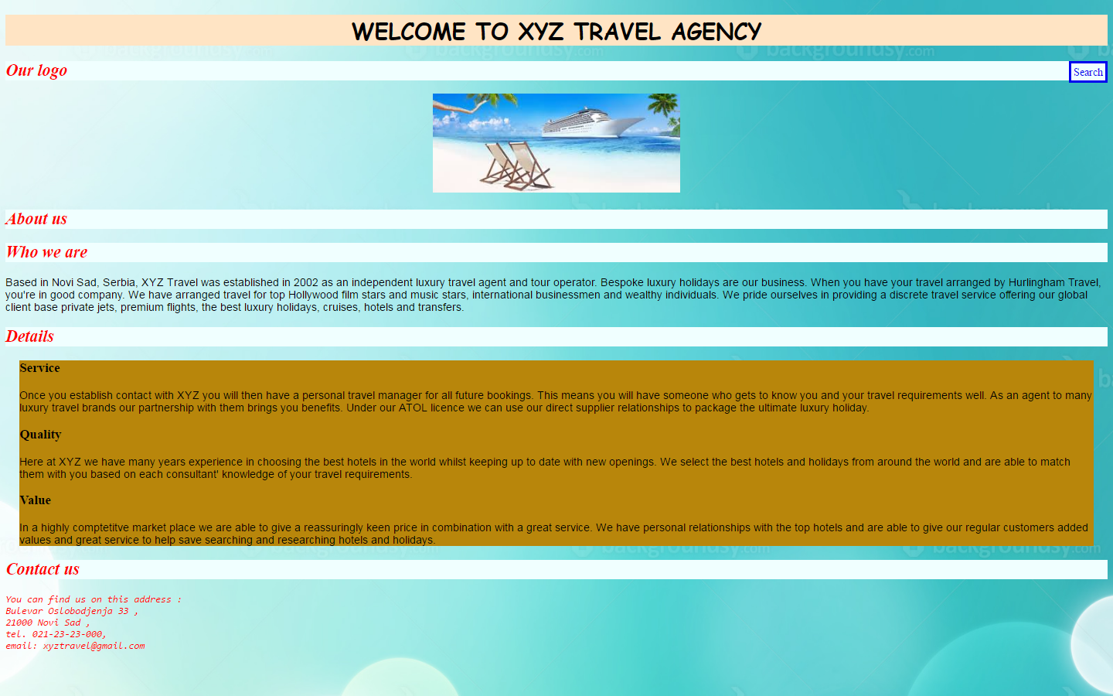

Picture 1 – miniproject4.jpg

Your job is to make new cascade stylesheet file and make some changes in web page design using CSS basics knowledge.

# Requirements for this project

Before you can start with this project you need to finished Introduction to CSS class.

**Tasks**

So your job is to do next :

1. Use newdesign.html page for this project.
2. First make CSS folder and make style.css file in this folder.
3. In newdesign.html call style.css as external link.
4. Now in style.css make simple selector for html and set margin and padding to 0;
5. Next make simple selector h1 with font family cursive, set text to center, put size to 2em and set background color to bisque.
6. Also make simple selector for h2 ,and set color to red, background color to azure and set font style to italic.
7. Put background image background-10.jpg in body of page.
8. All paragraphs need to have size of 16px and to have Arial as first option , Helvetica as second option ,and if non of them exists put default sans-serif font.
9. For contact text set red color, put 14px size text, italic style and sans-serif font. Do this using one property named font.
10. For logo change position and set image in center of page.
11. In details class selector set background color to darkgoldenrod and set this div to have margin 20px from both left and right side of page.
12. Change inside contact div tags <pre> to <p> , save and refresh page and see what happens. After that change back <p> to <pre> tag and save page.

**Additional tasks**

1. Make changes on design for link reference Search.
2. In style.css make pseudo class a:link. Change link design so that you remove underline in link , make border around link ,and use padding 3px. Link must be set on right side of page.
3. Also when user make mouse over this link color need to change in darkred color.

Your result should look like on picture miniproject4.jpg

Good luck!

# Timeline

You will have 2.5 hours to finish this job.

This timeline is for main parts of the task. Bonus parts should be implemented only if there is extra time left.

# Tools

## IDE and Source Control

You can use either Atom or Brackets tool for development during this project

ATOM - <https://atom.io/>

BRACKETS - <http://brackets.io/>